Daily Encouragement – 22nd November
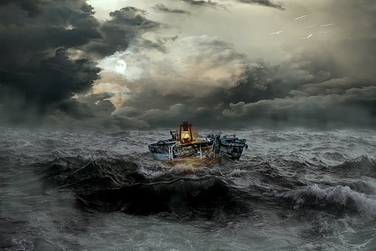
Mark 4: 35-41
That day when evening came, he said to his disciples, “Let us go over to the other side.” Leaving the crowd behind, they took him along, just as he was, in the boat. There were also other boats with him. A furious squall came up, and the waves broke over the boat, so that it was nearly swamped. Jesus was in the stern, sleeping on a cushion. The disciples woke him and said to him, “Teacher, don’t you care if we drown?”
He got up, rebuked the wind and said to the waves, “Quiet! Be still!” Then the wind died down and it was completely calm.
He said to his disciples, “Why are you so afraid? Do you still have no faith?”
They were terrified and asked each other, “Who is this? Even the wind and the waves obey him!”
We are to fear but not to be afraid: “The fear of the Lord is the beginning of wisdom” (Proverbs 9.10), yet as we will be reminded in the Christmas story in the weeks ahead we are constantly urged, “Do not be afraid!”
In this passage, Jesus doesn’t just rebuke the wind and the waves; there’s a mild rebuke for the disciples too – “Why are you so afraid?”. This doesn’t appear to help them, though, as they then become terrified!
The passage is a great reminder that in fact fear in its right place is godly. That right place is that we are to fear the Lord; that is the only fear we are to have. While I love to be reminded, and rightly so, that the Lord is my Abba, shepherd, friend, we would do well to remember that the Lord is always to be feared (do you remember Susan’s conversation with Mr Beaver in The Lion the witch and the wardrobe – is Aslan safe?).
However, we are not to be afraid. Jesus rebukes the wind and the waves because he is able to sleep in the middle of them. The solution to the wind and the waves facing the world today is to sleep(!); to rest, to abide in the presence of Jesus. That will grow our faith and give us the courage to stand up, to shine out, to declare that the Kingdom of God is at hand.
Father God we come before you are trembling and in fear of you, mighty creator. We recognise might and worship your majesty. Nothing is too great or terrifying for you. And so as we focus our gaze on you and rest in your presence, we know we need not be afraid. As the storms surround us and threaten to swamp us, we rest in your steadfast presence and release your peace and stillness over the storm. Amen
Christopher Pix

