Tuesday 7th April

Jeremiah 31: 3 - 6

The Lord appeared to us in the past, saying:
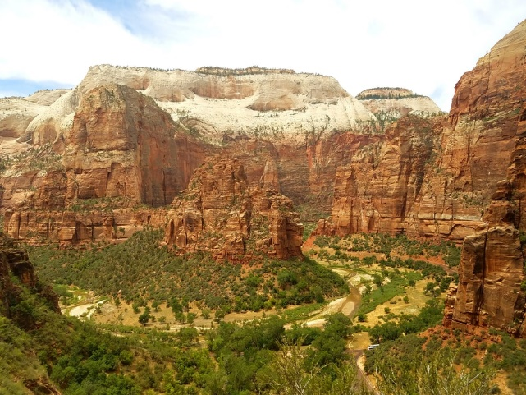
‘I have loved you with an everlasting love;
I have drawn you with unfailing kindness.
I will build you up again,
and you, Virgin Israel, will be rebuilt.
Again you will take up your tambourines
and go out to dance with the joyful.
⁵ Again you will plant vineyards
on the hills of Samaria;
the farmers will plant them
and enjoy their fruit.
There will be a day when watchmen cry out
on the hills of Ephraim,
“Come, let us go up to Zion,
to the Lord our God.”’

When Jeremiah wrote these words, the people of Israel were at a low ebb. They had gone away from the ways of the Lord, and Jeremiah had been warning that walking away from the source of all love and peace and joy and life is not a good idea! However, even in the midst of this situation, God promises his beloved people that they will be rebuilt – that a time of joy and fruitfulness will return. God’s goodness, mercy and grace are so extraordinary, that even when our pain is self-inflicted, he comes to the rescue. And at the end of the passage, a return to the Lord is foretold, as the people go up to Zion which symbolises the presence of the Lord. That part is crucial – returning to the Father. Come, let us return to the Lord! He is the one who rebuilds. He gives back ‘the years that the locusts have eaten’ (Joel 2: 25). Yesterday we talked about a ‘reset’ in different areas of life during this time. Perhaps that is like demolishing. Today, let’s pray for the rebuilding. That when this time is at an end, the rebuilding of lives, businesses and communities will be on a firm Foundation.

Lord God, we praise and thank you for the enormity of your love and mercy! Thank you that there is no person, or no situation that is beyond your reach. Thank you for the grace that we have received from you. We pray today for a great return to you, the source of all life and love. That we would say again ‘Come let us go up to Zion, to the Lord our God’.
We pray today for all those who are struggling. We ask for your help and blessing to rest upon those whose businesses have failed and whose livelihoods look uncertain. We ask you Father to encourage them with your love. We ask that this promise of restoration will bring encouragement today. We thank you for the many new, creative, community-centred initiatives that are arising at this time and pray for your blessing on them. We continue to pray for our Prime Minister, and all others who are currently afflicted by this virus. Jesus, we ask for your healing power to be released to them today. In your name. Amen

