Daily Prayer & Encouragement
Tuesday 10th November 2020

“... and SURELY I AM with you ALWAYS,
to the very end of the age” (Jesus’ words)
Matthew 28 verse 20

Sometimes it’s hard to see what God’s doing, but in ALL things He can bring about a greater good.

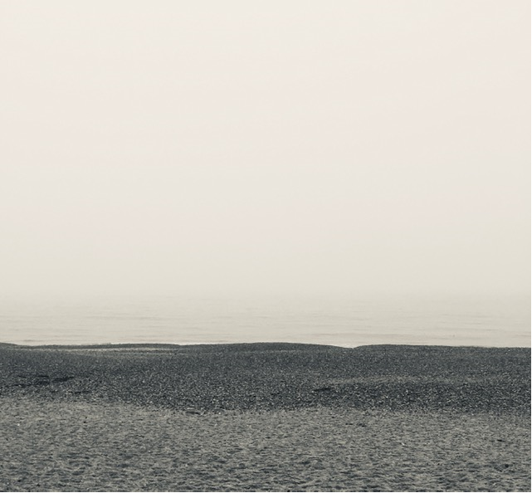

Take a look at the picture. We know there is a horizon (where the sky touches the sea) but the sea mist could make us think it’s just not there.

Faith is being sure/certain of what we CANNOT see and having confidence in what we hope for (Hebrews 11:1). In difficult times we may feel ‘misted up’, but have Faith! God is just like the horizon - ALWAYS there, and, if we know Him as LORD and Saviour, He is ALWAYS WITH us; an ever present help in times of trouble! (Psalm 46:1)

We may be in “Lockdown 2”, but be assured - God is NEVER locked down! Good News! It’s usually in moments of trial and the unthinkable that God demonstrates His compassion, does the ‘impossible’, and shows just how AWESOME He is!

When Jesus fed the 5,000+ (Matt 14) the crowds were hungry. Despite the disciples looking at the natural (5 loaves and 2 fish), Jesus had COMPASSION and from what seemed an impossible situation, fed them all with SURPLUS to spare!

When the crowds were moved to a place where they were totally dependent on the LORD, mighty and surprising things happened!

Then comes the question “but that was then, what about now?” Well, my friend, Jesus the Messiah is the SAME yesterday, TODAY and forever! (Hebrews 13:8). We have today the SAME God of Compassion, the SAME God of miracles and, what’s more, it’s IMPOSSIBLE for God to lie (Hebrews 6:18) - Hallelujah!

Be confident in the knowledge that our LORD IS with us, regardless of how things may look ‘in the natural’.

Some ‘homework’ for you all …

Place the verse below somewhere where you can see it (e.g. fridge or car visor) so you’re reminded of God’s promise.
OR
If you feel like ‘going for it’, email or text it to a friend or work colleague; someone who is yet to know Jesus, and tell them that you’ve thought of them through lockdown and want them to feel encouraged.

‘If you say “The LORD is my refuge”, and you make the Most High your dwelling, NO harm will overtake you, no disaster will come near your home’
(Ps91:9-10)

May the LORD bless you in this day

Paul Bliss

