Friday 12th June
Romans 15: 4-6

Such things were written in the Scriptures long ago to teach us. And the Scriptures give us hope and encouragement as we wait patiently for God’s promises to be fulfilled.
May God, who gives this patience and encouragement, help you live in complete harmony with each other, as is fitting for followers of Christ Jesus. Then all of you can join together with one voice, giving praise and glory to God, the Father of our Lord Jesus Christ.
What gives you hope and encouragement? I suspect that if I spoke to each of you, there would be a little list of things that have kept you hopeful and encouraged through these past weeks, from acts of kindness, video calls or phone conversations with friends and family, having a good laugh, to meeting online for services, and prayer. In these verses, Paul says that the Scriptures give us hope and encouragement. I know that many of you have found that to be your experience. We read in the Scriptures of all the promises of God, and we read of the character of God, and we know that he always keeps His promises. So we can hold on to Him in hope. And as we fix our eyes on Him to sustain us we are united around Him. If we are directing our hearts towards him, we should find that we grow closer to each other.
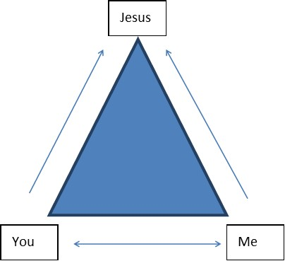
The Lord’s desire for His people is that we should live in complete harmony. That does not mean that we should all be the same, look the same, or think the same – together we have the mind of Christ. I don’t need to tell you that there is such a need for that harmony to be demonstrated in a divided world.
Lord Jesus, just before you died, you prayed for the unity of your followers. Forgive us for the times that we have not valued one another. We ask you to help us to keep our hearts full of your Word and directed towards you. We pray that we would take hope and encouragement as we listen to your voice. We ask that together your people will lift up one voice, giving praise and glory to God. That we will be a sign of what you can do on the earth. For your glory we pray. Amen

