Daily Encouragement – 21st November

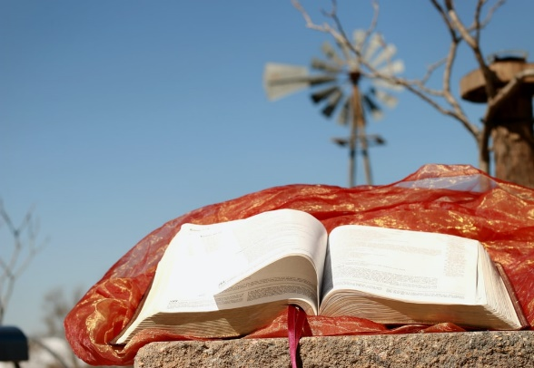
Hebrews 11: 1-2
"Now faith is confidence in what we hope for
and assurance about what we do not see."

The writer of Hebrews lists many Old Testament characters – Abel, Enoch, Noah, Abraham, Jacob, Joseph, Moses, the Israelites, Rahab and others – people whose faith in God had the most remarkable outcomes.
I particularly like the idea of Noah doing something seemingly ridiculous, ostentatious and totally inappropriate, but the Bible says he did this in Holy fear – and God shared the details of the ark with him and His plans for mankind. Noah had confidence in God's direction, and God gave the rainbow as a sign of His everlasting covenant between God and all life on earth. And what about the Israelites who 'by faith passed through the Red Sea as on dry land'!
In this unprecedented pandemic with awful consequences we are in a position of begging to see God, and only in very recent days have we been told that there are vaccines soon to be available. We thank God for the skills and talents of the scientists and the commitment, skill and compassion of frontline workers.
In chaos and suffering it's been hard to see God at times, but we must have faith in Him, and I find it easier to have faith in what is unseen – the unknown way ahead – when I lift my eyes to Him and remember his promises, as in Isaiah 42 v 16:
"I will lead the blind by ways they have not known, along unfamiliar paths I will guide them". Let's lift our eyes and voices to him now in praise!
PRAYER
O Lord my God, when I in awesome wonder,
Consider all the works thy hand hath made,
I see the stars, I hear the mighty thunder
Thy power throughout the universe displayed.
Then sings my soul, my Saviour God to thee,
How great thou art. How great thou art.
Jenny Thornton

