Wednesday 15th July - Mike Orman, Worship Pastor

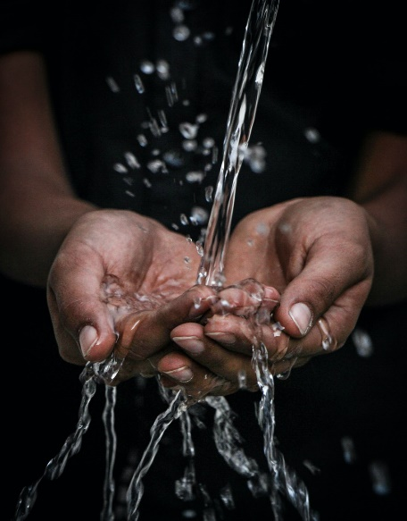
John 4:13-14

Jesus answered, "Everyone who drinks this water will be thirsty again, but whoever drinks the water I give them will never thirst. Indeed, the water I give them will become in them a spring of water welling up to eternal life."
Since the football season has resumed after the pause during lockdown, they have introduced two drinks breaks during the game. It's a chance for the players to take on much needed refreshment during the matches being played out in the warmer summer months. But, as Jesus points out to the Samaritan woman he was speaking to in this reading from John 4, anyone who drinks of that water will be thirsty again. It only satisfies our thirst for a moment and then we need some more. In life we often look to satisfy our deepest longings with things that don't provide the lasting satisfaction we are really hoping for. We have to keep going back for more. Whether it's more wealth, more possessions, a better car, a different relationship, more 'likes' and followers on social media - there's a longing for more.
The singer, Robbie Williams, has always been quite open about his search for something deeper than this world can offer - something that lasts. He has spoken quite honestly in the media. One of his gigs was at Knebworth House playing to thousands of fans and there is a moment of raw, honest soul bearing in the middle of the gig during a song called "Feel". One of the verses goes...
I just wanna feel
Real love and the love ever after
There's a hole in my soul
You can see it in my face
It's a real big place
And Robbie then goes off script and calls out in the middle of the song, surrounded by thousands of fans, "Hello? Is there anybody out there? Is there anybody out there?" He wasn't talking to the crowd - he was calling out to God - and yes, Robbie, He is out there and He's closer than you think!

I love the Message's take on the promise of God in Jeremiah 29:13:
"When you come looking for me, you'll find me. Yes, when you get serious about finding me and want it more than anything else, I'll make sure you won't be disappointed." God's Decree.
Robbie Williams has since done an Alpha course!
If you are looking for something that will satisfy, something that will last, something that brings real life - drink the water of life that Jesus offers. You won't be disappointed.

Jesus, thank you that you offer us something the world can never get close to - life in all its fulness and eternal satisfaction. We are sorry for times we have tried to satisfy our thirst with things the world tries to offer. Give us eyes today to see the people around us who are searching for something that satisfies, something that will last - and help us to point them to you, Jesus. Thank you that you'll make sure they won't be disappointed. Amen.

