Daily Prayer and Encouragement – Monday 7th December

Hebrews 10: 25

“Let us not give up meeting together, as some are in the habit of doing, but let us encourage one another- and all the more as you see the Day approaching.”

The above passage of scripture was written way before our lockdown systems came into operation restricting our present movements. Some people it seems, were neglecting to meet together- interestingly not through any outside influences such as we are experiencing. The writer was keen to rectify this situation and encouraged mutual love and good works towards others. Since the book of Hebrews was written we now have the amazing ability to meet together and share without physically meeting – through using the phone, email, and zoom connections. The lockdown in March has provided the circumstances for these to flourish and I have personally appreciated the daily messages from the leadership and currently through a variety of others.

Encouragement is important to us all with many examples in scripture of God’s encouragement to individuals with phrases like “Take courage!” “Be strong!” The dictionary definition of courage is “the ability to disregard fear”- note not the ABSCENCE of fear but the ability to continue in the face of it.

Now there are two small words which can be placed in front of courage – EN and DIS to give ENCOURAGEMENT and DISCOURAGEMENT -one positive and one negative. I guess for some the present circumstances of life may be overwhelming and a source of discouragement bringing all sorts of negative thoughts. BUT the scriptures invite us to take courage, be aware of others and to become encouragers because our God is a God of encouragement.

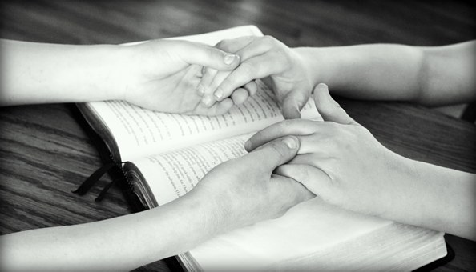
Prayer
Loving Heavenly Father thank you that You know all about us as individuals, You know our humanity and frame, and even the hairs on our head are numbered. Help us to realise afresh that nothing happens to us without Your knowledge. May this give us confidence to face the challenges of life with courage, knowing the support of others and Your guaranteed Presence. Amen

John Bemrose

